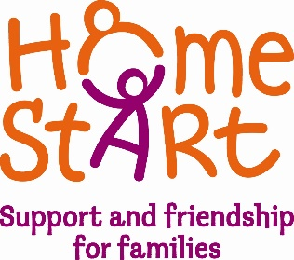

Home-Start York

Job Description

Job Title: Group Worker

Employer: Home-Start York

Responsible to: Senior Organiser

Responsible for: Families and Volunteers

Hours of work: 6 hours per week- Flexible/Term time only

Principle purposes of the job:

To deliver group support services including:
- Provision of child focussed play/educational activities to support development.
- Parental guidance to support child development.
- Supervision and support for volunteers.
- To work with guidance from the senior organiser in the planning and delivery of group support.

Main responsibilities:

- To work within Home-Start’s standards and methods of practice including Equal Opportunities, Safeguarding and Promoting the Welfare of Children, Confidentiality and all mandatory policies.
- Work in close co-operation with the volunteers and other scheme staff.
- To be responsible for upkeep of database and produce monthly attendance reports.
- Work in partnership with other family support agencies, as appropriate.
- To make contact and establish needs for new referrals to attend the group(s).
- Review family’s needs on an ongoing basis and feed back to organisers monthly.
- To maintain contact with scheme organisers regarding referrals, during family’s individual support.
- To welcome all parents/carers to the group, recognising the importance of their role as the prime carers of their children.
- To be aware of group dynamics ensuring the groups provide a non-judgemental environment for children and their parent/carer.
- To provide a safe, stimulating environment for children and their parents.
- To be vigilant about the upkeep of equipment ensuring good standards of safety and hygiene are followed.
- To encourage the active participation of parents/carers in their child’s play and other activities as appropriate.
- To provide opportunities for external agencies to offer advice/information to families.
- To promote the use of suitable toys, books and activities and encourage the use of local resources e.g. Libraries and Children Centres etc.
- To complete a Risk Assessment prior to each session.
- To keep a register at each session detailing names of all those attending, including visitors/speakers with an evaluation of each speaker.
- To record any accidents/incidents in the Accident or Incident Book and report as appropriate.
- To respond, record and report appropriately all Safeguarding Children/Child Protection issues.
- To liaise with the Senior Organiser regarding budgets.
- To promote the work of Home-Start with referrers.
- To be willing to undertake training as appropriate, including safeguarding/child protection.
- To attend regular supervision sessions.
- To regularly attend staff meetings (once a month).
- To advertise and promote group and linked events on social media/press/tv/radio including creating and designing appropriate advertising materials.
- To attend promotional events as required.
- To provide cover in the absence of other group worker, liaise with each other regularly and to provide a collaborative service.
- Flexible working required (term time only).
- Any other duties/responsibilities relating to the group work.

